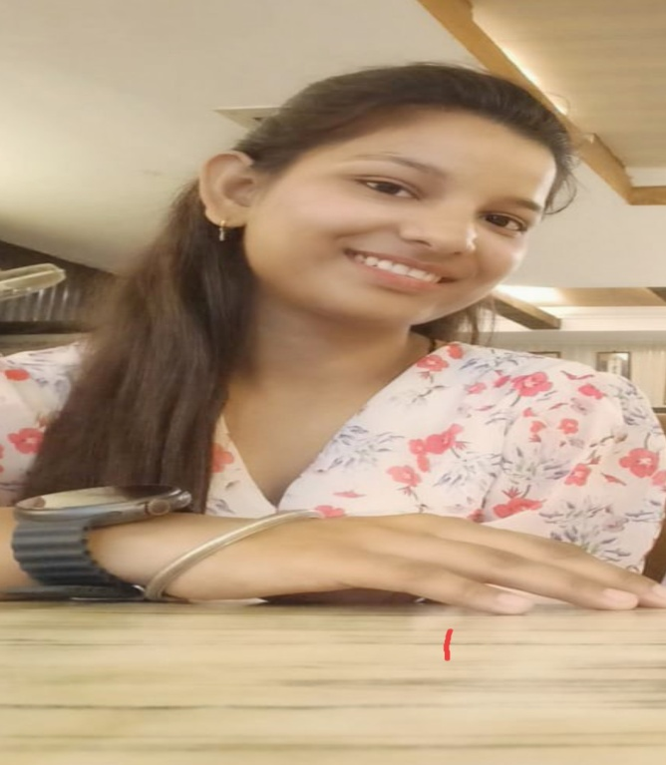0

I am a MCA student currently studying in COER University .I am capable of working under pressure and have a high sense of responsibility .I am hardworking and driven individual who isn’t afraid to face a challenge . I am self motivated and reliable .I am fully passionate about my work and career

**SUMMARY**

हिंदी

ENGLISH

**LANGUAGE**

**Frontend** **technologies** **:-**HTML , CSS , Java Script

**Back-end Languages :-**

C,C++,Python

**Database systems :-**

SQL,MY SQL,Mongo DB

**SKILLS**

**8923029657**

[**pragyachauhan133@gmail.com**](mailto:pragyachauhan133@gmail.com)

**Haridwar Uttarakhand**

**PRAGYA CHAUHAN**

|  |  |  |  |
| --- | --- | --- | --- |
| Course/Degree | School/University | Grade/Score | Year |
| 10th | UK Board | 77.8% | 2018 |
| 12th | UK Board | 70.2% | 2020 |
| Bsc | HNBGU | 7.0/10 | 2023 |

**PERSONAL DETAILS**

Date of birth : 04-08-2002

Father’s Name : Mr Rajeev Chauhan

Mother’s Name :Mrs. Sukarma Chauhan

Marital status : Single

Nationality : Indian

**EDUCATION**

**EXPERIANCE**

One month virtual WEB DEVLOPMENT internship in CODSOFT.